Project Plan Straight Through Processing

JS Bank Limited


Project Plan Straight Through Processing

JS Bank Limited

Project Approach………………………………………………………………1

Project Time Estimate…………………………………………………………...2

Project Plan Straight Through Processing JS Bank Limited

Project Approach

JS Bank embeds RCCC components with Integration Software. RCCC embedded application can directly send/receive messages from PRISM server. Settlement confirmations/error messages can be easily received by the RCC embedded application. Integration Software will be making a copy of all the messages exchange in between RCC embedded application and PRISM server. RCCC components installed on JS Bank computer.

However, since the JS bank has opted option of RCCC (Remote Client Communication Component); therefore JS Bank is going to develop “INTEGRATION SOFTWARE” to cater the need of “API” which currently provided by SBP as part of PRISM to perform multiple functions, which includes but not limited to authorization of MT102, MT103, MT202, Balance enquiry, monitoring of inflows and outflows, free format messaging and any other functionality which is currently available in the PRISM API provided by SBP Upon receiving the RTGS instructions from any of the partner application, the integration software, will convert the message based on its payment type (as per SBP’ prescribed formats of MT-102, MT-103 and MT-202) and push the outward MTs to PRISM by following
all the relevant protocols to meet SBP’ requirements. Similarly, the integration software should have the capability to receive incoming

Ref | Interfacing | Scope Requirement
A | Integration with Banking modules
  Home Remit | - APIs (Integrator’s own)
  Treasury | - APIs (Integrator’s own)
B | Integration with Financial System | API
C | Integration with SBP-RTGS(PRISM) | Through RCCC/API provided by SBP

Project Plan Straight Through Processing JS Bank Limited

Architectural Diagram
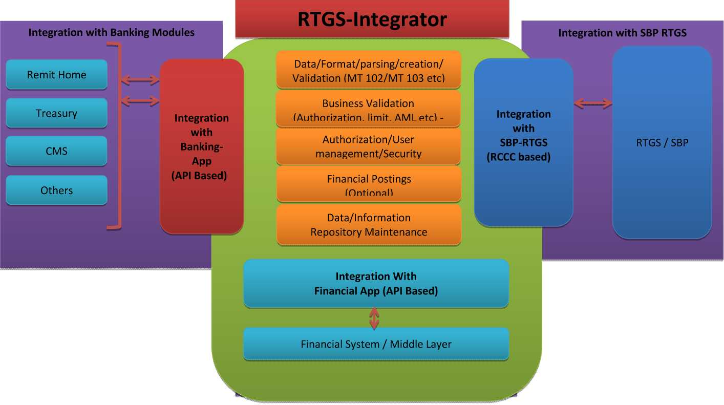

Project Plan Straight Through Processing JS Bank Limited

Project Time Estimate

The calendar time estimates to complete the assignment for MT 102

No | Stage/Activity | Weeks | From Date | To Date
01 | Requirement Finalization | 02 | 01-Feb-2016 | 11-Feb-2016
02 | Design & Development | 06 | 14-Feb-2016 | 25-Mar-2016
03 | Client/SBP Site – Changes/Verification | 03 | 25-Feb-2016 | 17-Mar-2016
04 | Deployment & Configuration | 02 | 17-Mar-2016 | 31-Mar-2016
05 | System Integration Testing | 01 | 31-Mar-2016 | 07-April-2016
06 | User Acceptance Testing (SBP/JSBL) | 02 | 07-April-2016 | 21-April-2016
07 | Walk through/Dress Rehearsal | 01 | 21-April-2016 | 28-April-2016
08 | Live Cut-Over |  | 30-Apr-2016

The calendar time estimates to complete the assignment for MT 103, MT 202 & all Formats.

No | Stage/Activity | Weeks | From Date | To Date
01 | Requirement Finalization | 02 | 01-Feb-2016 | 11-Feb-2016
01 | Design | 06 | 14-Feb-2016 | 25-March-2016
02 | Deployment & Configuration | 04 | 16 May-2016 | 13-june-2016
03 | System Integration Testing | 03 | 13-june-2016 | 04-July-2016
04 | User Acceptance Testing (SBP/JSBL) | 03 | 04-July-2016 | 24-July-2016
05 | Walk through/Dress Rehearsal | 02 | 24-July-2016 | 08-Aug-2016
 | Live Cut-Over | 01 | 11- Aug-2016

Project Plan Straight Through Processing JS Bank Limited

